From：<https://www.cnblogs.com/houchaoying/p/9096118.html>

环境：centos7.6 jdk1.8 mysql5.7

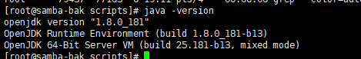



环境准备过程：jdk rpm安装

Myslq安装：

# 安装mysql

yum -y localinstall http://dev.mysql.com/get/mysql57-community-release-el7-7.noarch.rpm

yum repolist enabled | grep "mysql.*-community.*"

yum -y install mysql-community-server mysql-community-devel

# 启动并添加开机自启

service mysqld start

systemctl enable mysqld.service

# 找到随机密码

grep 'temporary password' /var/log/mysqld.log >./password.txt

# 修改默认mysql密码

在/etc/my.cnf [mysqld] 后面添加一行：skip-grant-tables //不输入密码直接登录

重启mysqld：systemctl restart mysqld

进入数据库：mysql

修改密码：use mysql;

update user set authentication_string = password('123456'), password_expired = 'N', password_last_changed = now() where user = 'root'; //修改密码为123456

重启数据库，之后就可以使用新密码登录了

软件下载：<https://product-downloads.atlassian.com/software/jira/downloads/atlassian-jira-software-8.8.0-x64.bin>

破解包下载：链接：https://pan.baidu.com/s/1ggtAR0v 密码：p4gh

部署：

# 创建所需库以及账户，授权

create database jira default character set utf8 collate utf8_bin;



grant all on jira.* to 'jira@’%' identified by “123456”;



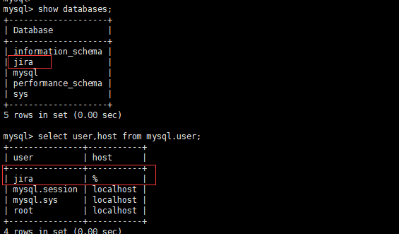

# 查看系统位数以及下载对应版本jira安装包

Getconf LONG_BIT



Jira下载地址：<https://product-downloads.atlassian.com/software/jira/downloads/atlassian-jira-software-8.8.0-x64.bin>

下载jira:wget <https://product-downloads.atlassian.com/software/jira/downloads/atlassian-jira-software-8.8.0-x64.bin>

# 开始安装

Chmod 755 atlassian-jira-software-8.8.0-x64.bin



./ atlassian-jira-software-8.8.0-x64.bin

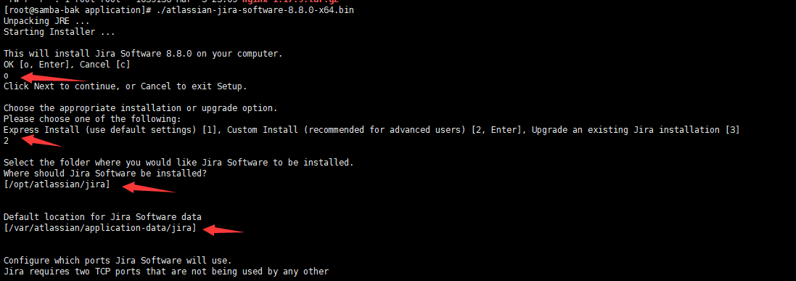

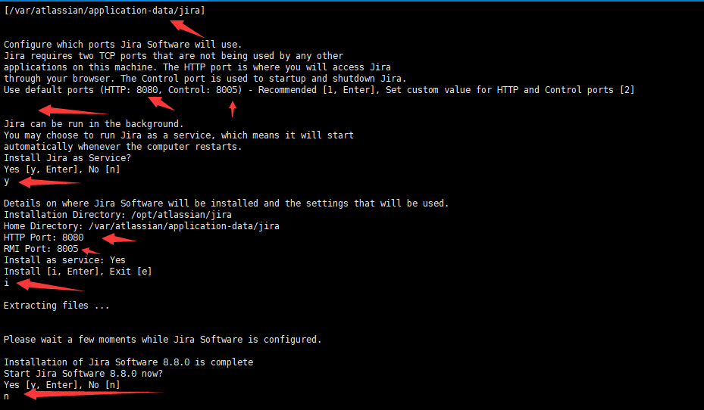

这里基本采用默认配置，若有需求可自行配置

Jira安装目录：/opt/atlassian/jira和/var/atlassian/application-data/jira

Jira监听端口为：8080

Jira主要配置文件为：/opt/atlassian/jira/conf/server.xml

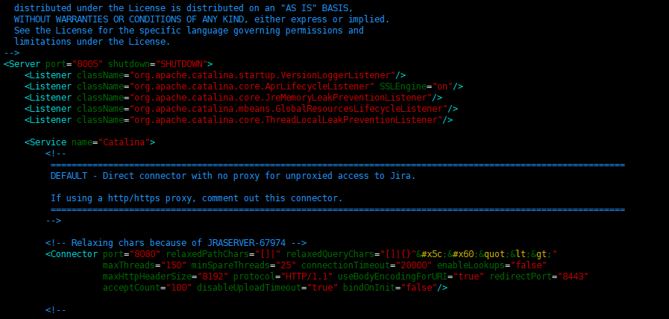

启动jira：

cd /opt/atlassian/jira/bin/

./ start-jira.sh

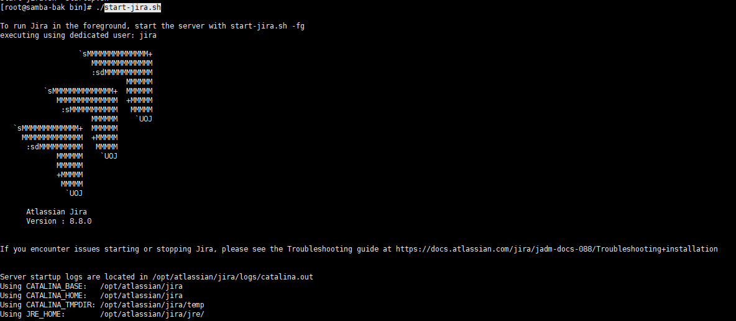

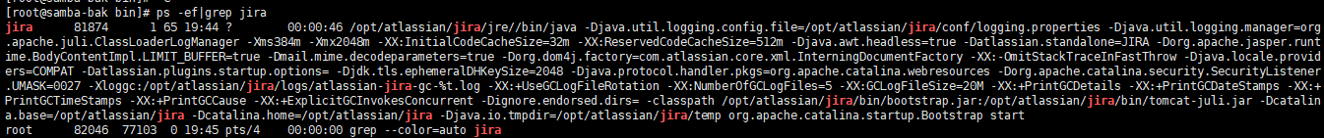

停止jira，并开始破解

./stop-jira.sh

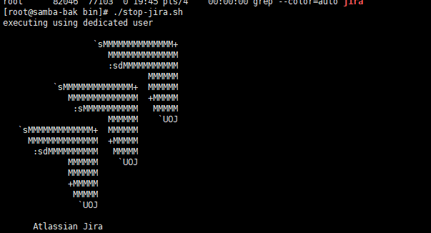

把破解包里面的atlassian-extras-3.2.jar和mysql-connector-java-5.1.39-bin.jar两个文件复制到/opt/atlassian/jira/atlassian-jira/WEB-INF/lib/目录下。

其中atlassian-extras-3..2.jar是用来替换原来的atlassian-extras-3.2.jar文件，用作破解jira系统的。而mysql-connector-java-5.1.39-bin.jar是用来连接mysql数据库的驱动软件包。

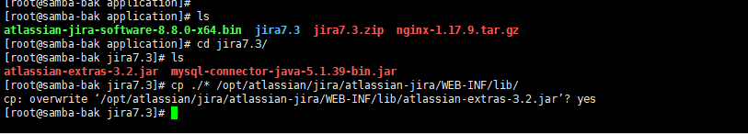

重新启动jira，然后在浏览器输入IP+8080

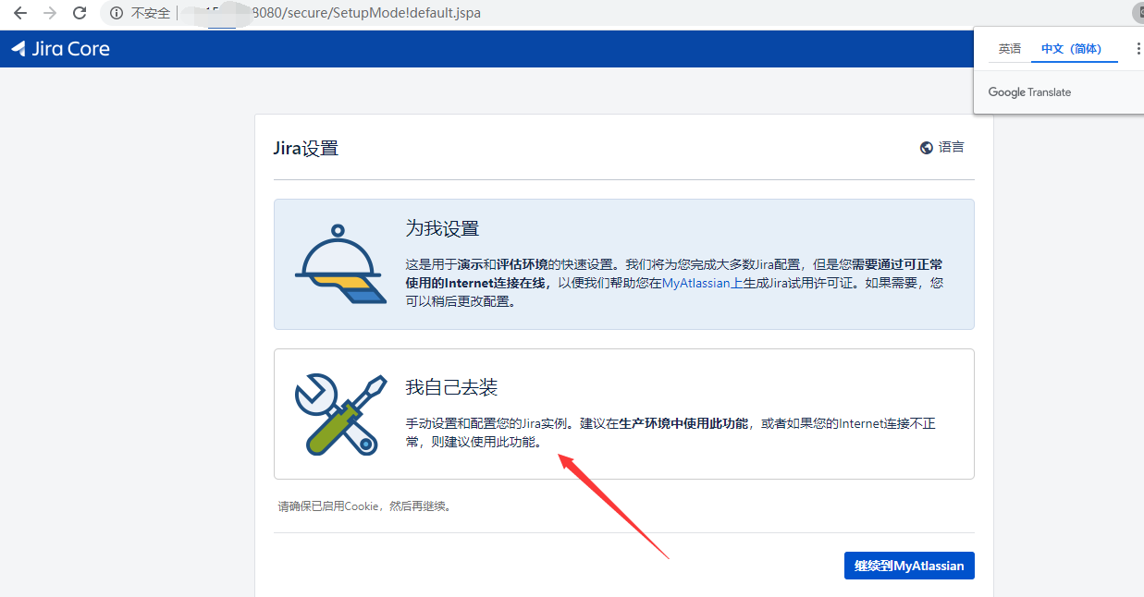

配置数据库，修改/etc/my.cnf文件

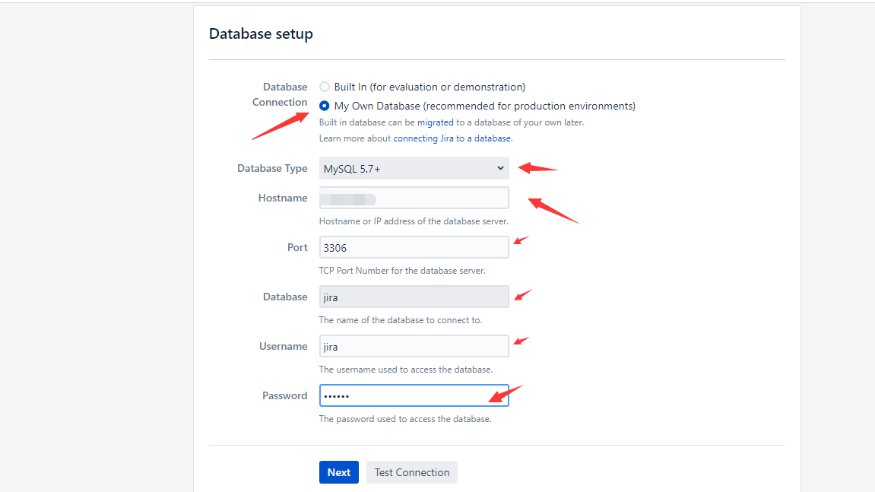

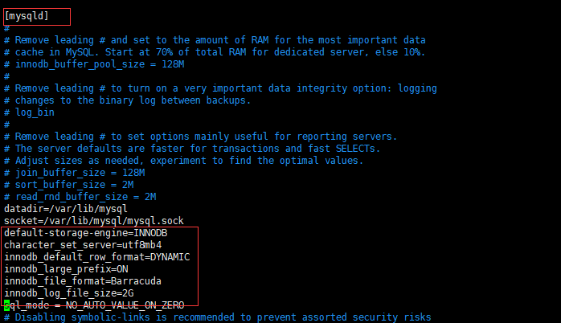

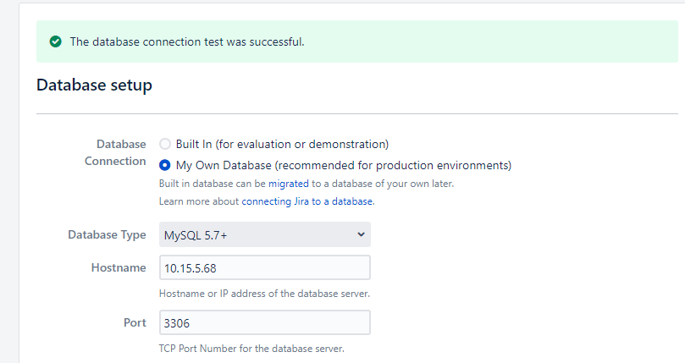

测试连接成功

接下来点击下一步即可，由于要初始化数据库，所以需要点时间

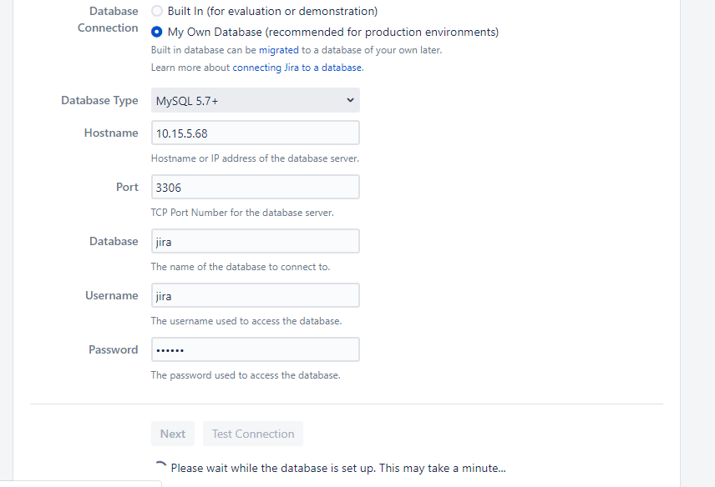

秘钥获取

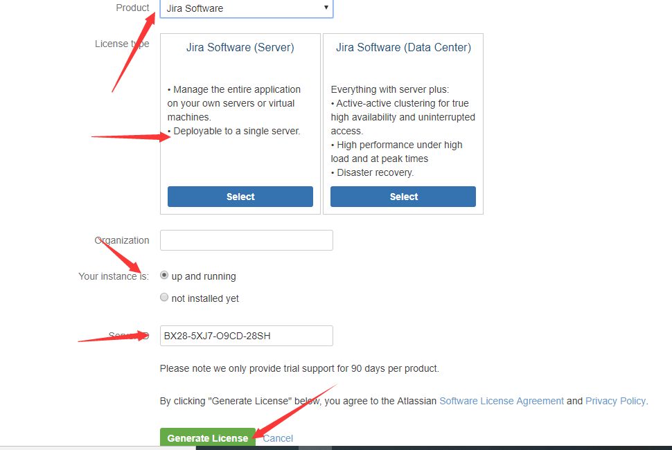

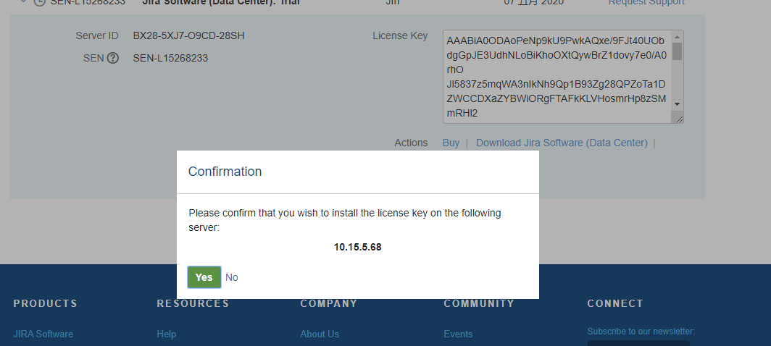点击yes即可自动复制licence

然后下一步即可

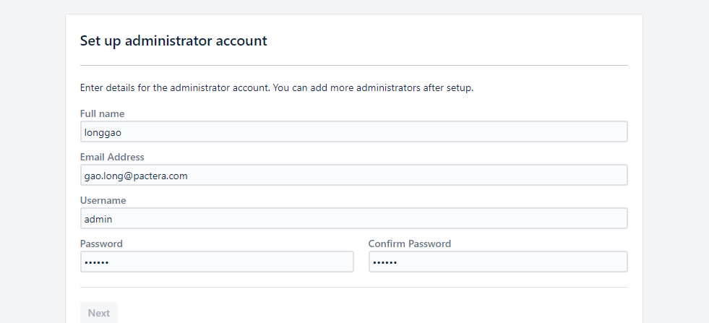

设置管理员账号

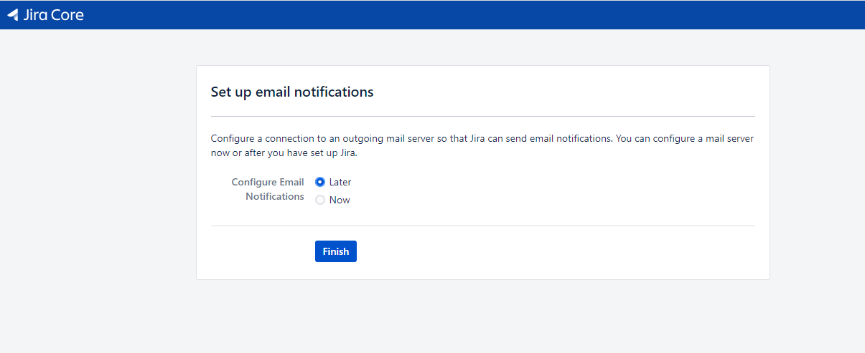

设置邮箱

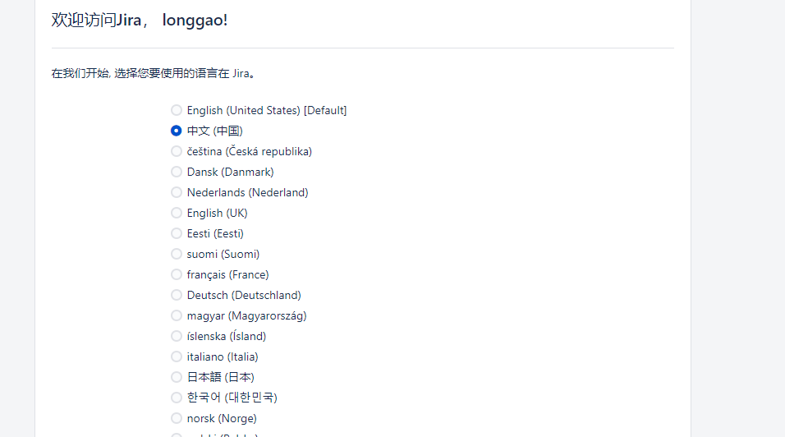

选择语言，中文

基本完成，破解也ok

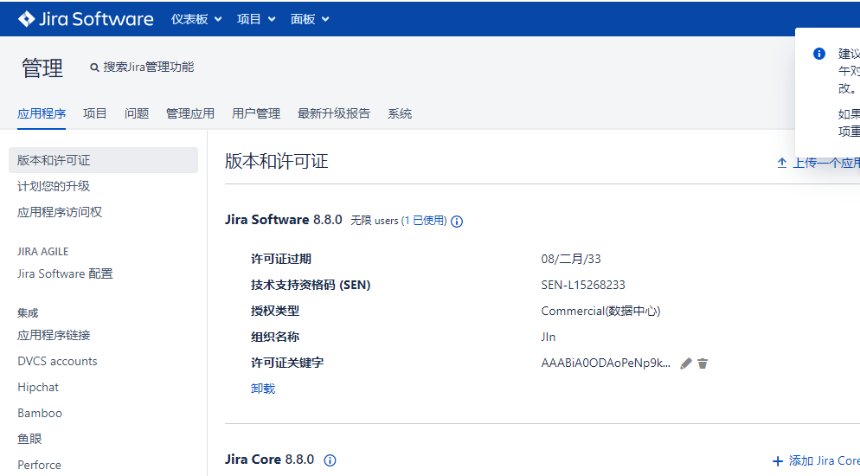

修改内存：vim /opt/atlassian/jira/bin/setenv.sh

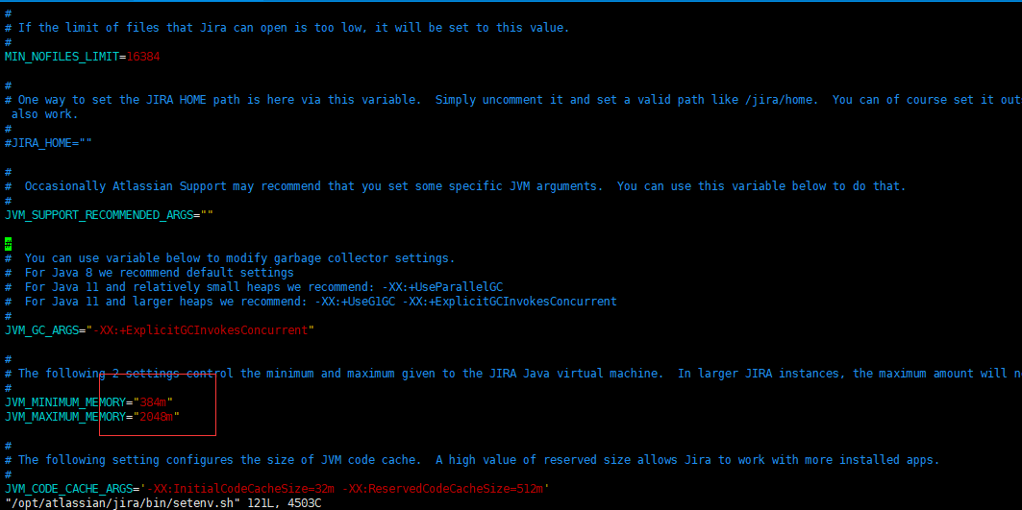

日志查看：

tail -f /opt/atlassian/jira/logs/catalina.out